

Elements of AIML

Assignment - 1

  Topic - Predicting Carbon Emissions for Climate Action

Name: Ishita Pradhan

Batch: 11

Sap ID: 500119414

Roll No: R2142230350

**SDG 13 : CLIMATE ACTION**

**Context**

**What Are Carbon Emissions?**

Carbon emissions primarily refer to the release of carbon dioxide (CO₂) into the atmosphere, mainly due to human activities like burning fossil fuels for energy, transportation, industry, and deforestation. These emissions are a significant driver of global warming and climate change. The goal of global climate action is to **reduce carbon emissions** to mitigate the harmful impacts of climate change, including extreme weather events, rising sea levels, and biodiversity loss.

**Why Predict Carbon Emissions?**

Accurate predictions of carbon emissions from various sectors (e.g., transportation, industrial activities, energy production) based on historical and environmental data can help governments, organizations, and researchers better understand emissions patterns and guide policies for **reducing carbon footprints.**

**Brief Description of the Project**

This project uses machine learning to predict CO2 emissions based on Metric tons of CO2e per capita. By using training models the goal is to forecast future emissions, identify key drivers, and assess the effectiveness of climate policies. The insights generated help inform climate change mitigation strategies and support data-driven policy decisions for sustainable development and emissions reduction.

**Step 1: Data Acquisition**

I am using the dataset titled **“Countrywise Production-Based CO2 Emissions”** from Kaggle. This dataset contains information about CO2 emissions by country, region, and sector over time, which can be used to track the progress of global CO2 emissions reductions, and make predictions for future emissions.

We can use this dataset to build a machine learning model that predicts CO2 emissions based on historical data and the influencing factors like energy consumption, GDP, and population.

[Countrywise Production-Based CO2 Emissions](https://www.kaggle.com/datasets/iamsouravbanerjee/production-based-co2-emissions)

**Step 2: Define the Methodology and Objectives**

**Objective**:  
We want to predict **CO2 emissions** based on different features such as economic, industrial, or geographical data. Our objective is to build a **regression model** to predict **CO2 emissions per capita**.

**Methodology**:

1. **Data Acquisition**: Download the dataset and load it.
2. **Preprocessing**: Clean the dataset (handle missing values, encode categorical features, etc.).
3. **Feature Engineering**: Select features relevant to CO2 emissions prediction.
4. **Model Selection**: Train multiple regression models (e.g., Linear Regression, Random Forest, Gradient Boosting).
5. **Evaluation**: Use performance metrics like Mean Squared Error (MSE), Mean Absolute Error (MAE), R², and Cross-Validation to compare the models' effectiveness.

**Step 3: Data Preprocessing**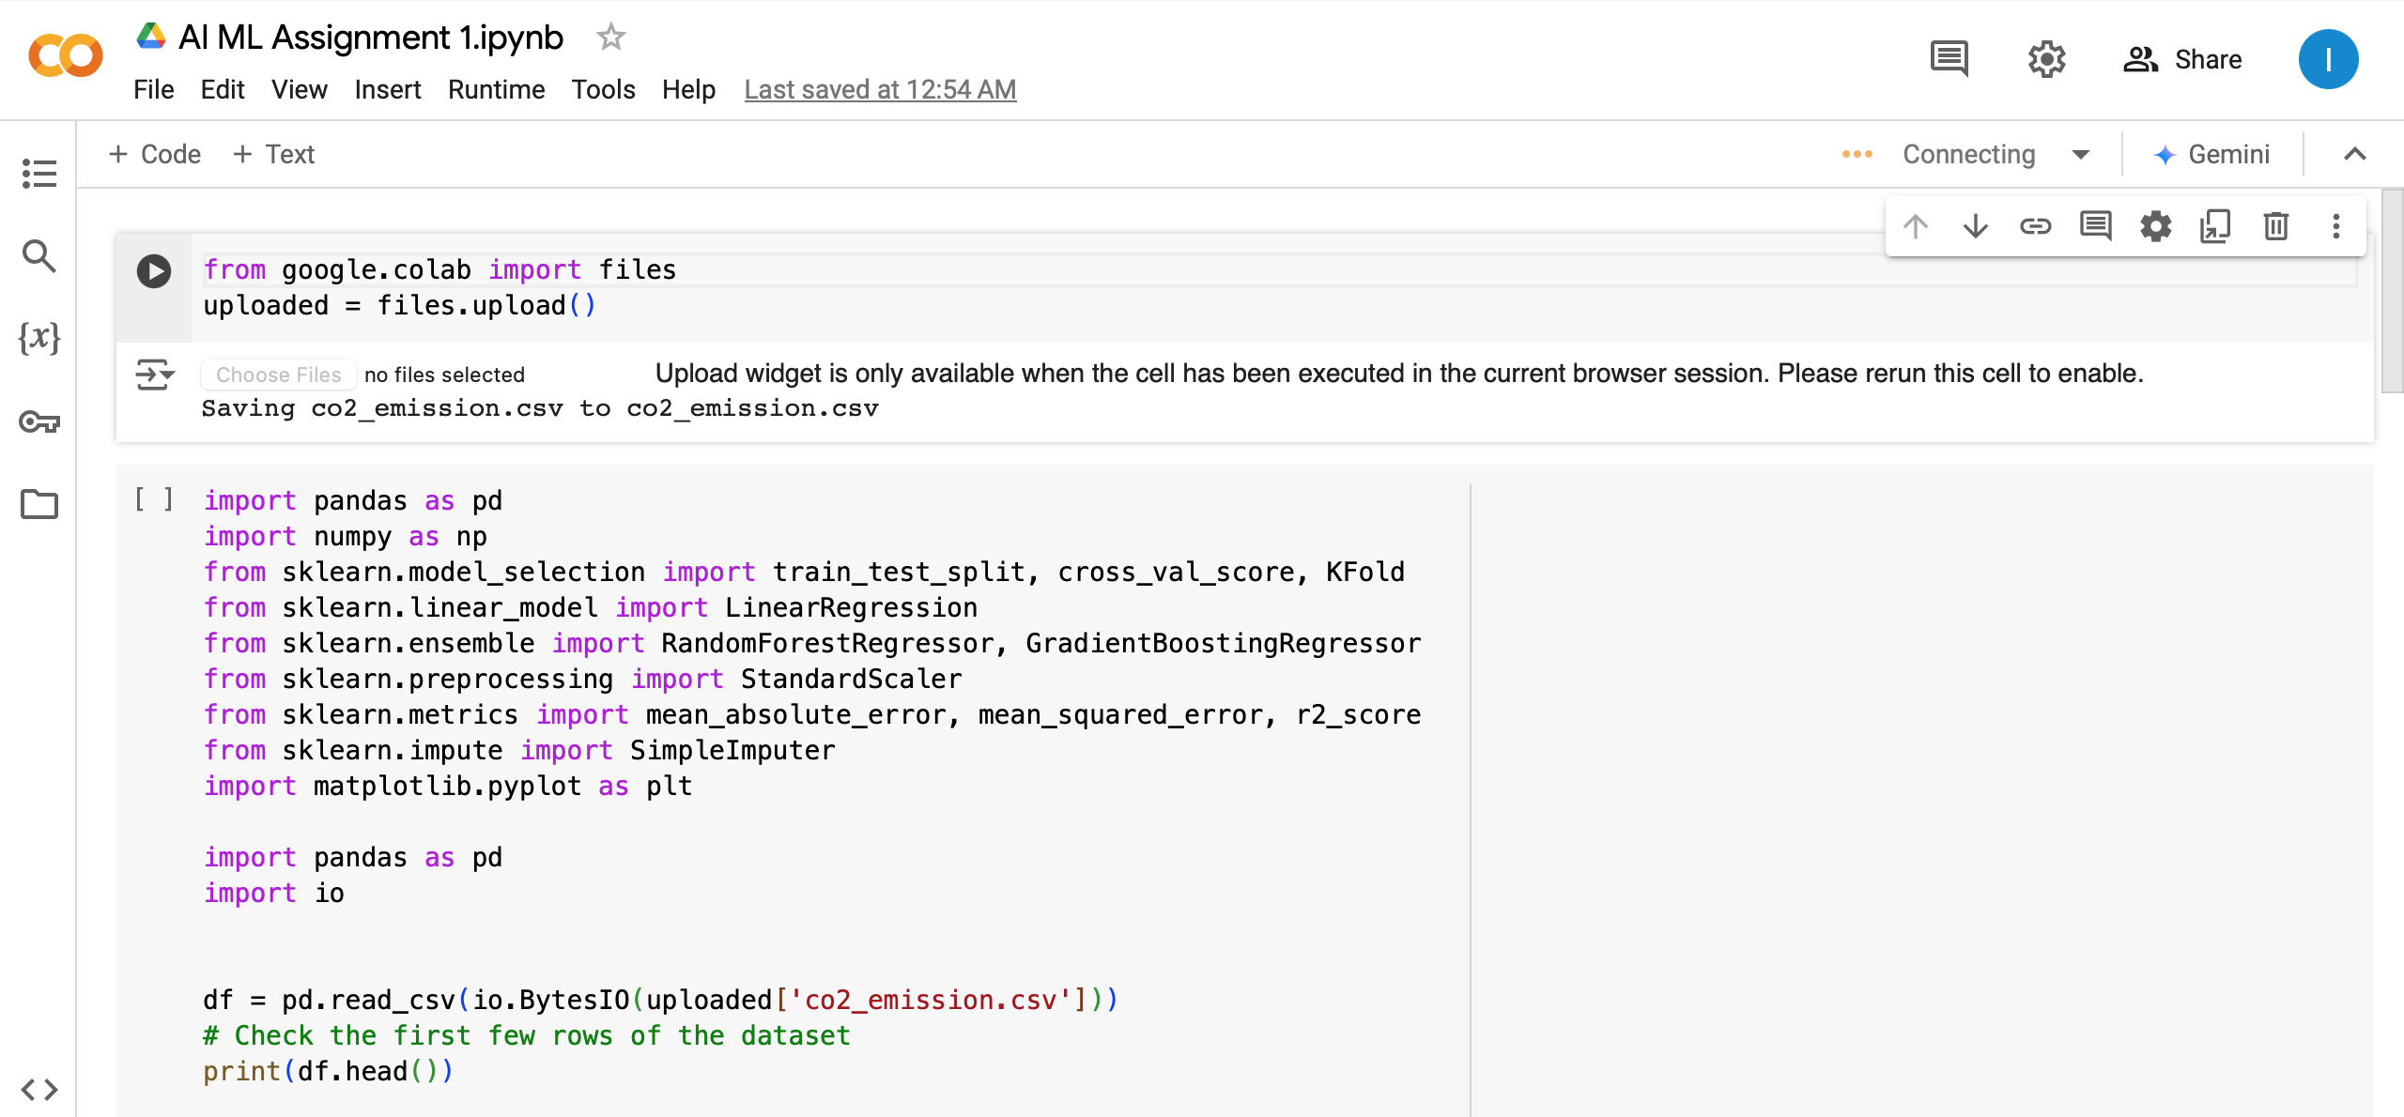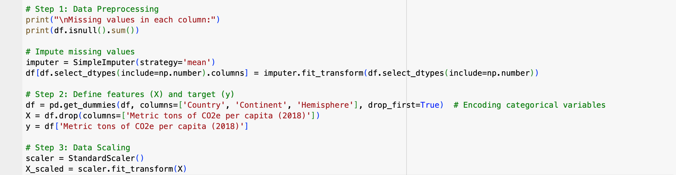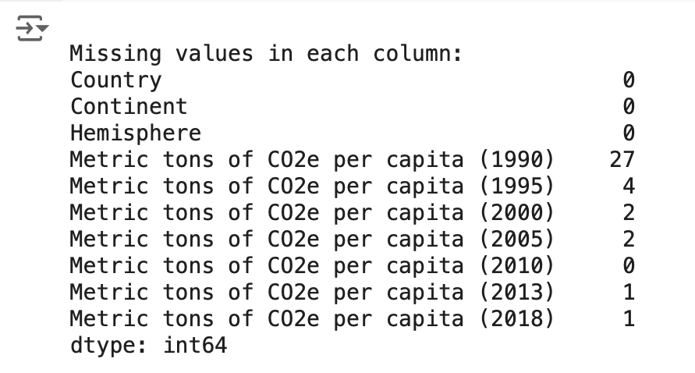

**Output -**

**Step 4: Use Multiple ML Methods and Validate Using K-Fold Cross Validation**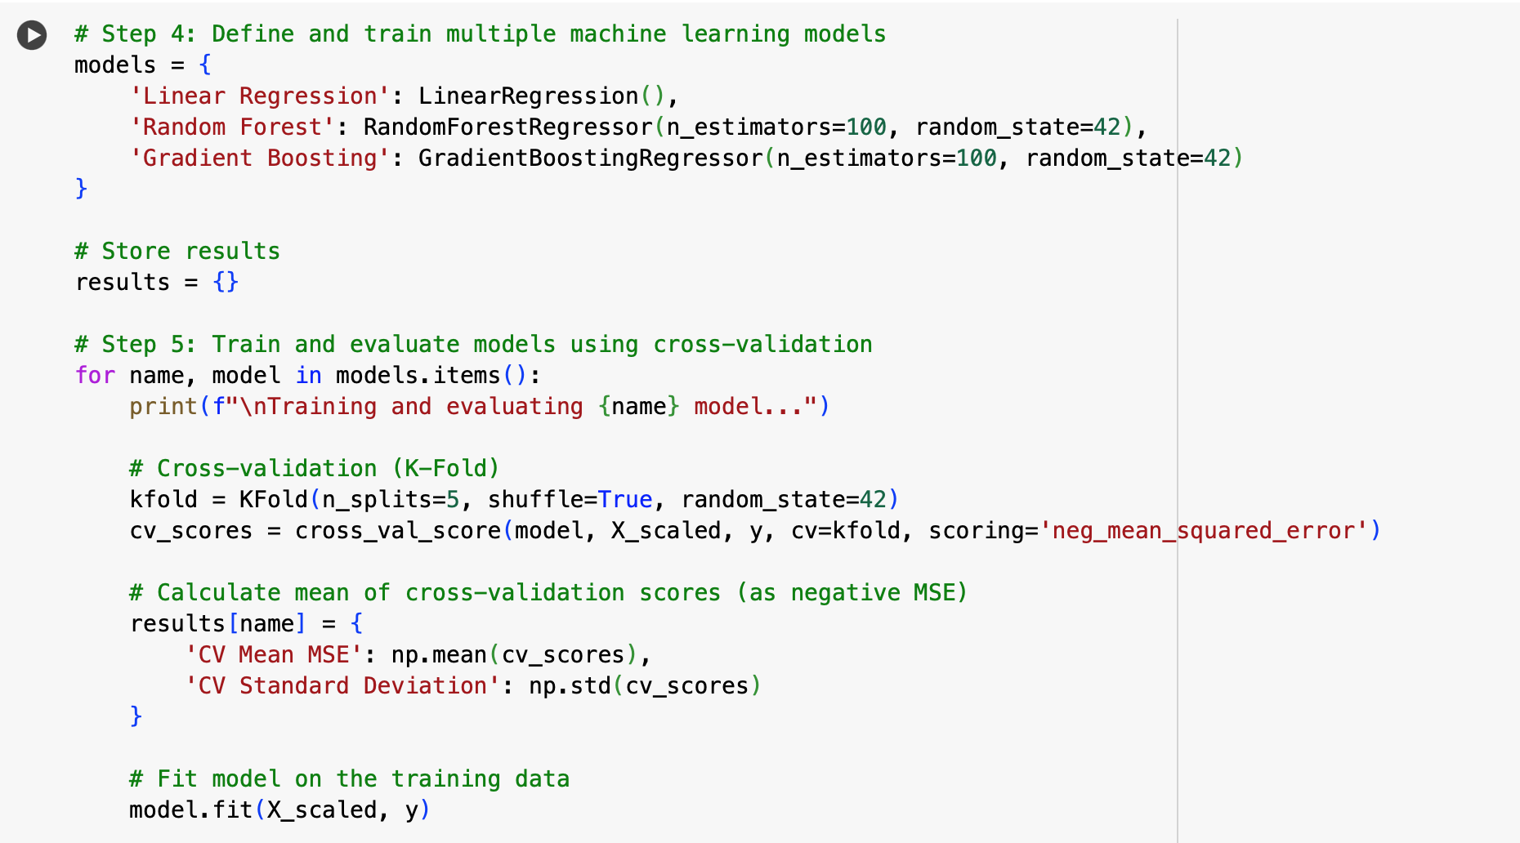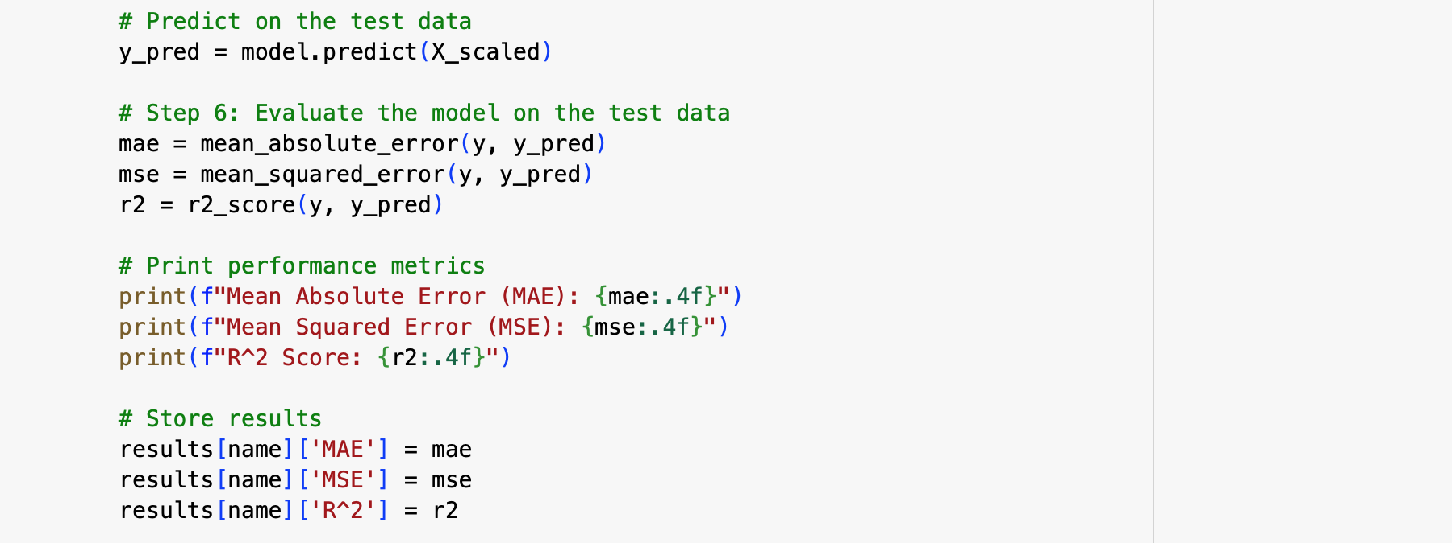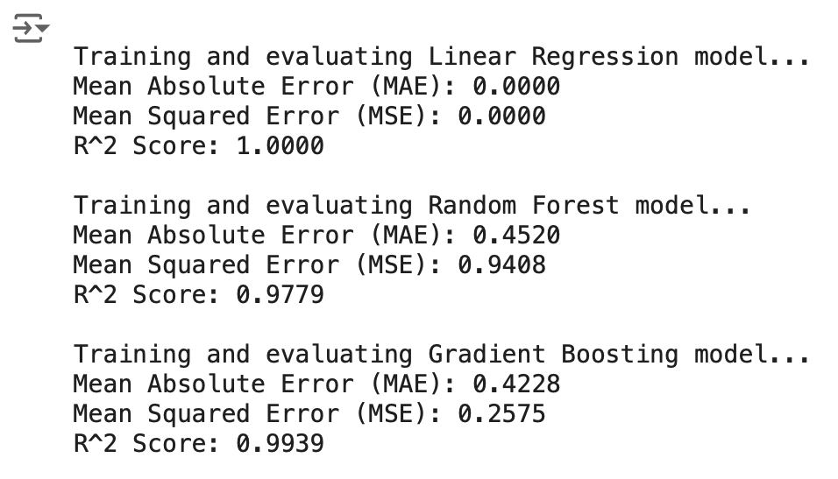

**Output -**

**Step 5: Compare the Results Using Suitable Performance Metrics**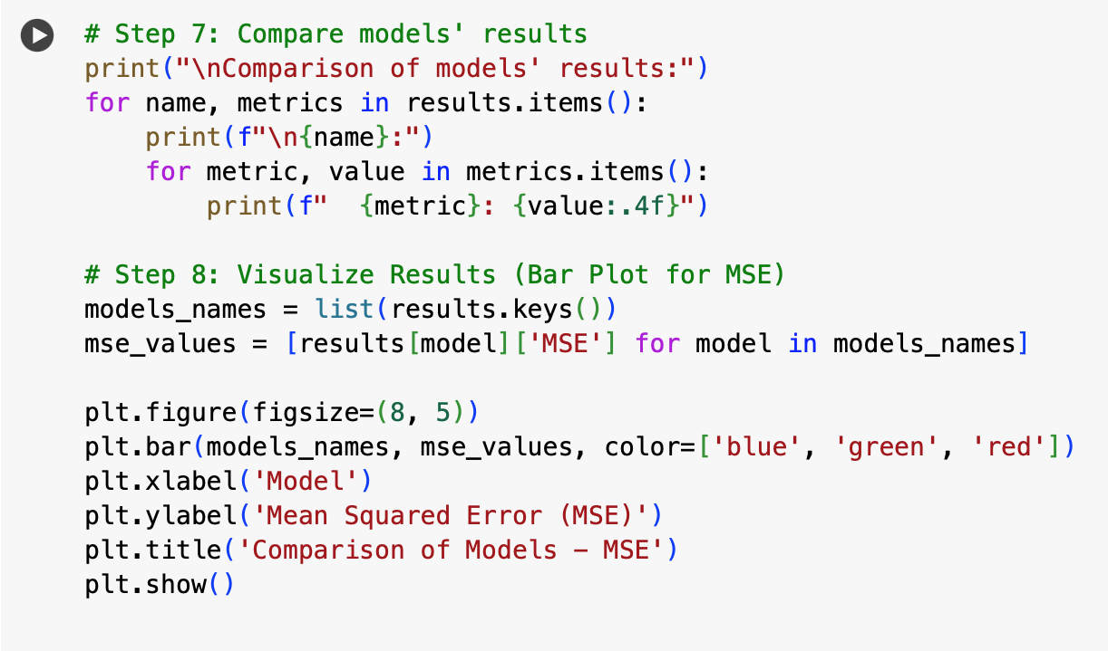

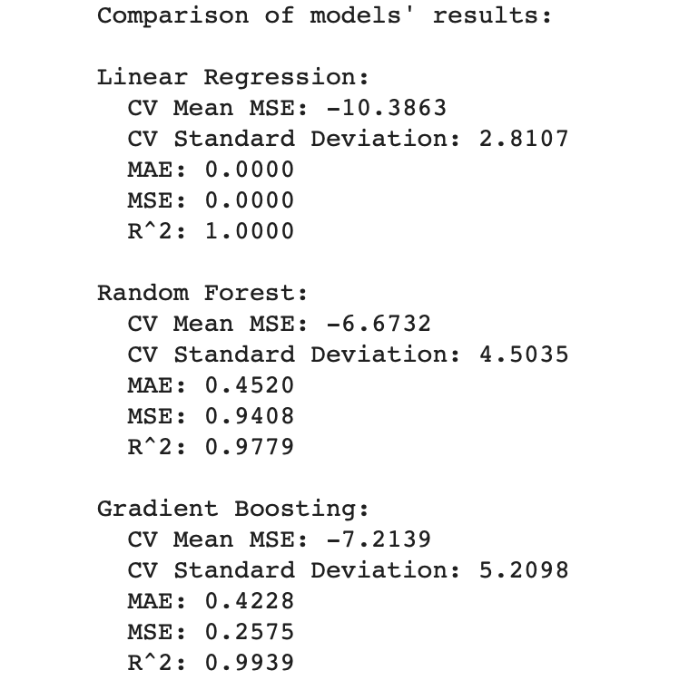

**Output -**

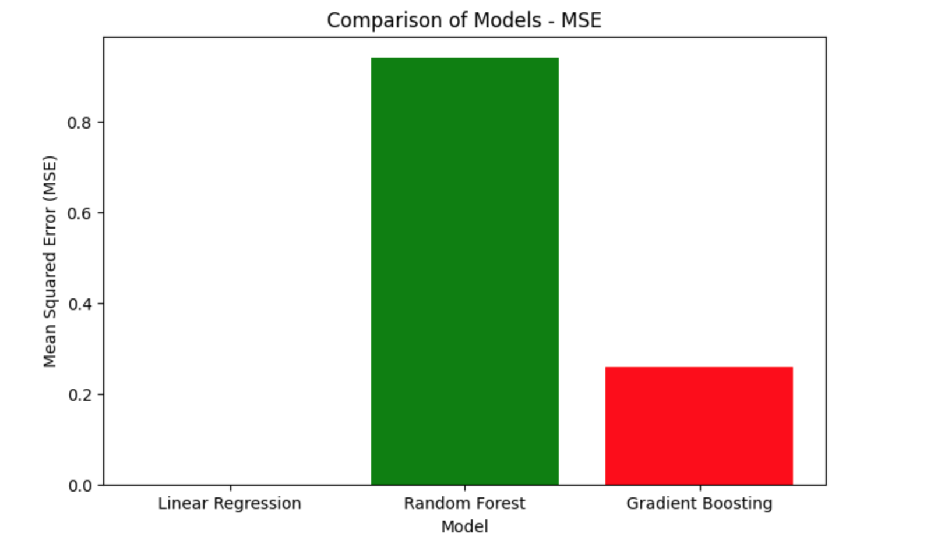**Real-Life Applications of this model for Climate Change:**

* **Predict Future CO2 Emissions**:
  + Helps predict future emissions based on historical data, aiding long-term climate planning.
  + Allows countries to forecast how emissions will change with policy changes (e.g, renewable energy adoption).
* **Informed Decision-Making for Policymakers**:
  + Provides data-driven insights for policymakers to shape effective climate action plans.
* **Identifying Emission Hotspots:**
  + Pinpoints key sectors or regions contributing the most to CO2 emissions (e.g., energy, transportation, manufacturing).
  + Helps prioritize interventions where they will have the biggest impact on emissions reduction.
* **Tracking Emission Reduction Progress:**
  + Monitors the progress of emissions reduction over time and helps evaluate whether current climate strategies are effective.
  + Tracks whether specific policies or initiatives are working, or if adjustments are needed to meet climate goals.